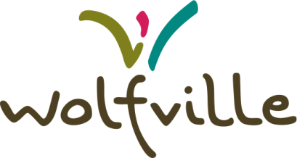
Employment Opportunity:
Senior Planner

The Town of Wolfville is inviting applications for a Senior Planner for a fulltime term position of three (3) years.
The position will manage development planning and other planning projects as assigned.

The position will interact with staff across the organization, Council, and the public. Experience in development planning and local government are essential for this role, along with relevant qualification and previous planning experience at a senior level.
The successful candidate will review, process, and formulate planning opinions on complex planning proposals and projects within a community planning context (proposals and projects to include plans of subdivisions applications, municipal plan and zoning amendment applications, site plan applications, development agreement applications and other projects as assigned).
Resume with a cover letter will be accepted up until March 29th , 2024, at 4:00 pm and can be submitted by mail or by email to:

e: kouterleys@wolfville.ca
(subject line for emails: Senior Planner)

A full job description is available on request and all applicants are thanked for their interest, however, only those who are selected for an interview will be contacted.

The Town of Wolfville is committed to providing a healthy, safe and supportive workplace where diversity is valued and where everyone is treated with respect and dignity.

The Town of Wolfville welcomes and encourages applications from Black, racialized and Indigenous Peoples, 2SLGBTQ+, newcomers to Canada, and People with Disabilities.

If you are a member of a group that has been historically excluded from opportunities, we encourage you to self-identify in your cover letter or resume and to share your pronouns.

If you require any accommodation to support submitting your application or navigating the process, or if you would like start a conversation about employment opportunities, please reach out to the Clerk, Laura Morrison, lmorriosn@wolfville.ca

