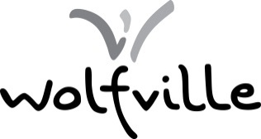

TOWN OF WOLFVILLE

Public hearing

TAKE NOTICE at 6:30 PM, on Tuesday, December 20th, the Town of Wolfville will hold a Public Hearing in the Council Chambers of Town Hall, 359 Main Street, regarding the following:
- A rezoning application to rezone 120 Highland Avenue (PID 55271563) from Medium Density Residential (R-3) to Institutional General (I-1), pursuant to MPS policy 8.6.4.13.
- A Land Use Bylaw text amendment to permit Daycares in the I-1, I-2, and C-2 zones ‘As-of-Right’ and in the R-3 and R-4 zones by ‘Site Plan Approval’, pursuant to MPS policy 11.4.1.
- A Land Use Bylaw text amendment to only require architectural plans prepared by a licensed Architect for development agreement or site plan approval applications within the Design Guidelines areas, pursuant to MPS policy 11.4.1.

Further information may be obtained by contacting Devin Lake, RPP, MCIP, Town Planner, 200 Dykeland Street, Wolfville, NS weekdays between 8:30 am and 4:30 pm, by phone at (902) 599-3210 or by e-mail at dlake@wolfville.ca.

