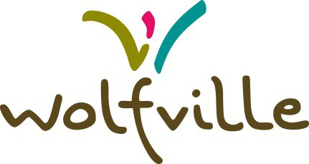
GRANTS TO ORGANIZATIONS
CAPITAL FUNDING APPLICATION FORM

Supporting volunteer, community-based organizations is often fundamental to maintaining our quality of life. The one-time special funding (capital) requests provision within the Grants to Organizations Policy is intended to provide organizations with an avenue to periodically request additional funds to support capital campaigns and projects. Operating expenses and special events and initiatives will not be considered as eligible expenses. Only one application per organization may be submitted per year. Only one application per organization may be approved every eight years.

Please note that changes to the Grants to Organizations Policy have been in effect since March 22, 2016. You can find the revised policy at wolfville.ca.

Please complete the attached form and forward to:

Department of Community Development
Town of Wolfville
200 Dykeland Street
Wolfville, Nova Scotia
B4P 1A2

Phone: (902) 542-5767
Fax: (902) 542-5066
Email: nzamora@wolfville.ca

1) ORGANIZATION INFORMATION

Name of Organization:
Contact Person:
Mailing Address:
Email address:
Telephone:

Is your organization a registered charity?
If yes, what is your CRA Charitable Status Registration Number:

2) Application Information

Please provide detailed purpose and description of the request:

What is the target demographic that this request would serve?

What would the tangible benefits be to the community?

3) Application Checklist

Completed application form
Detailed budget including all anticipated revenue sources\
Timeline of project
Previous year’s financial statements
Confirmation of partner funding (if applicable)

4) EVALUATION PRINCIPLES
Please detail below how your program or event will meet the principles listed on page 4 of this application.

1) Program/ Service Obligation

2) Council Strategic Plan

3) Public Need/Benefit

4) Human Development and Inclusion

5) Quality of Life for the community

6) Alternative Providers

7) Financial Need

8) Economic Impact to the Town

9) Environment Sustainability

5) Funding Request
Total funding requested of the Town: $__________________
Total capital costs of project: $__________________
Total project costs: $__________________

6) GRANT APPROVAL
Grant funding is subject to councils approval of the Community Partnership Program and as a result the Town of Wolfville may not be able to provide the total amount requested in a given year. If there are changes to the Community Development Program, applicants will be notified.

7) CERTIFICATION
I certify that, to the best of my knowledge, the information provided in this application is accurate and complete and is endorsed by the organization which I represent.

Name Title

Signature Date

