**Housing Accelerator Fund & Municipal Planning Document Review Summary of Approach and Next Steps**

**Introduction**

Wolfville is a vibrant community and sought-after place to live. However, decades of slow housing construction and more recent rising housing costs, driven by rapid population growth across Nova Scotia, have made it timely for the municipality to update its planning documents to better serve the community.

To meet the diverse housing needs of families, young professionals, seniors, and students, the Town is using the Housing Accelerator Fund (HAF) as a tool to support more inclusive development.

As part of the HAF agreement, the Town is considering an Action Plan that includes revising parking requirements, reducing development barriers, promoting non-market housing, and allowing more than one unit in traditionally low-density zones. These changes are being formalized through new Municipal Planning Documents, including the Municipal Planning Strategy and Land Use Bylaw.

This summary outlines the progress made so far, highlights key considerations, and details the next steps in putting the Action Plan into action. For detailed information on the HAF and this process, [please visit Wolfville Blooms by clicking here.](https://wolfvilleblooms.ca/hafimplementation)

**What has been done to date?**

To support community education and obtain feedback, several forms of engagement have already happened. A report on engagement can be found here, but in summary:

* Stakeholder interviews have taken place with 13 landowners, Planning Advisory Committee (PAC) members, community members, and Town Councillors.
* Acadia University has been engaged on housing projects and paid parking.
* Four open houses were held in May 2025.
* A digital survey was circulated in May, which received 163 responses.
* Comprehensive information updates are posted to [Wolfville Blooms](https://wolfvilleblooms.ca/hafimplementation).

**What are the key themes & feedback**

**Heritage:**

* Emphasis on preserving both heritage and community character.
* Focus on protecting highest-priority buildings.
* Preserve key components of the Main Street’s character.
* Need for clearer design guidelines and owner engagement.
* Next: Identify and prioritize key heritage properties – outreach to owners.

**View Corridors**

* Protect existing view corridors of Blomidon along Main Street.

**Downtown Growth**

* Extend the existing downtown core commercial (C-1) zone to incorporate the existing neighborhood commercial (C-2) zone.
* Consider extending along Prospect and Gaspereau.
* Simplify setback rules to reduce confusion.
* Maintain single-family homes.
* Next: Bring forward examples and scenarios for clarity.

**Downtown Building Height**

* No support for 6 storeys—only in select locations for nonmarket housing (maybe).
* Support for 4 storeys if specific views are protected.
* Next: Show 4 vs 6 storey impacts, especially on Acadia-owned land.

**Parking**

* Openness to paid parking; need cost/benefit analysis.
* Concerns about creating new parking lots too early or unnecessarily.
* Trade-offs – parking, community space and revitalizing Front Street
* Next: Staff to provide cost estimates and timing of potential parking initiatives.

**Neighbourhood Zoning (R1 & R2)**

* Strong desire to retain Low Density Residential (R1) boundaries.
* Interest in allowing some flexibility (e.g., accessory units, home offices) within R-1.
* Public education needed around “As of Right” vs. “As of Right with conditions.”
* Need simple & clear regulations.
* Owner occupied dwellings are important.
* Next: Staff to analyze lot potential and clarify development possibilities/restrictions (eg lot sizes)

**Medium/High Density Residential & Mixed-Use Zones**

* Simplifying zoning to support development.
* Details of what and how development occurs are important.
* Need to understand the neighborhood impact of increasing the number of permitted units.
* Next: Clarify mixed use zone impacts, especially adjacent to residential areas.

**Short-Term Rentals (STR)**

* STRs are currently allowed in C1; also happening informally in R1.
* Mixed opinions—some rely on STR income to afford homes.
* Where would they be permitted and under what circumstances.
* Next: Improve public communication; possible workshop/special meeting; formal PAC recommendations by early October.

**What’s Next?**

Staff and consultants are preparing Council’s requests for more information such as visual examples, draft scenarios and clarified zoning maps. Detailed proposed amendments to planning documents are also being developed.

Another round of public engagement is being planned for October 29th and 30th at the Wolfville Legion to solicit feedback on the proposed changes. An updated timeline of engagement and communication will be posted on a [Wolfville Blooms](https://wolfvilleblooms.ca/hafimplementation) once ready. No decisions have been made at this point, and we will be reaching out to engage further.

**Next Steps and Schedule for Fall 2025**

**September**

* Staff will prepare the new Land Use Bylaw sections, approval scenarios and design guidelines to share with the Planning Advisory Committee (PAC) and Council.
* An update on this work will be provided at Committee of the Whole through the September CAO report.

**October**

* Special joint Committee of the Whole & PAC will be held to “workshop” the draft Planning Documents. Dates To Be Determined.
* The PAC will receive draft documents for further discussion and motions.
* A Town-wide mail-out on the new planning documents with links to more information will be sent out with dates for open houses.
* Open Housesto engage on new documents will be held on October 29 & 30. A communications strategy will go along with this.

**November**

* PAC: What We Heard from public engagement to be presented, possibly along with recommendations.
* Council: placeholder for considering PAC recommendations (this may take place in December).

**December**

* Council considers PAC recommendations
* The legislative process to adopt the new planning documents can begin.

**What is the process for adopting new municipal planning documents?**

**1) First Reading** (Introduction)

* This is anticipated to be in December or January, depending on how Council would like to proceed around the holidays.
* Council formally receives the proposed amendments to the Municipal Planning Strategy & Land-Use Bylaw.
* A vote is held to give the document “first reading.” If passed, this does not mean the document is approved, just that council is willing to consider it further.

**2) Public Hearing**

* After first reading, Council must hold a public hearing.
* Notice of the hearing must be published (usually in a newspaper and online) for a minimum of 14 days in advance of the hearing to give residents sufficient time to become aware.
* The public can speak directly to Council for or against the proposal.

**3) Second Reading** (Decision)

* Either immediately after the public hearing or at a separate meeting, Council will have an opportunity to debate the proposed amendments, considering public input and planning advice.
* A vote is taken on “second reading.” If a majority of council votes in favour, the planning documents are approved by council.

**4) Provincial Review**

* Amended Municipal Planning Strategies must be sent to Nova Scotia’s Minister of Municipal Affairs for review, via the Provincial Director of Planning.
* There, the planning documents are checked to confirm they follow provincial interests and legal requirements.
* Council cannot enforce the document until the Minister approves it.
* The amended planning documents come into force on the date of Ministerial approval.

**Links to find out more:**

[Events Calendar / Meeting Updates](https://wolfville.ca/events)

[Wolfville Blooms HAF Project Site](https://wolfvilleblooms.ca/hafimplementation)

[Town of Wolfville YouTube](https://www.youtube.com/@townofwolfville7090)

**Existing Zoning Map:**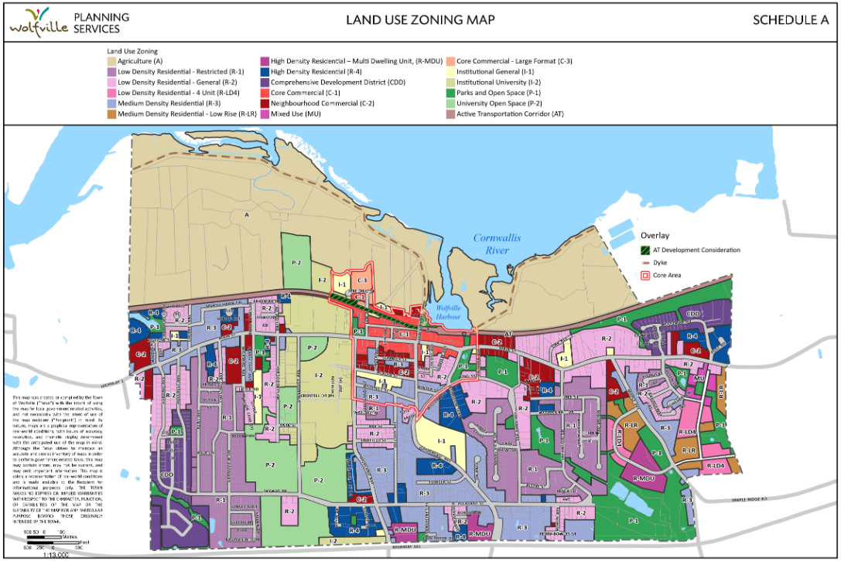

**Proposed Zoning Map (some edits required)**