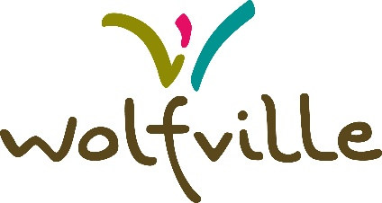

Land Acknowledgement

The Town of Wolfville acknowledges that we are located in Mi’kma’ki, the ancestral and unceded territory of the Mi’kmaq People.

As a town committed to reconciliation and respectful governance, we ask that all who live, work, and gather here do so with the Seven Sacred Teachings in mind: Truth, Honesty, Love, Courage, Respect, Wisdom, and Humility.

These teachings guide us in building a community rooted in understanding, fairness, care for one another, and for the land.

Please pause for a moment of reflection - How can we be good guests on this land?

Recognition of historic contributions

We also acknowledge the histories, contributions and legacies of the African Nova Scotian people who have shared these lands for over 400 years, and we acknowledge the shared ancestry of all people of African descent in Nova Scotia.

